

NAME: BISMA FATIMA
CLASS: CS A
ROLL NO: F24605036
COURSE: OBJECT ORIENTED PROGRAMMING
COURSE CODE: CS-123
LECTURER: MISS TAYYABA KALSOOM

IN LAB 06

TASK 01
PROGRAM
1. public class Car {
2. private String brand;
3. private String model;
4. private int year;
5.
6. // Default constructor
7. public Car() {}
8.
9. // Constructor with brand and model
10. public Car(String brand, String model) {
11. this.brand = brand;
12. this.model = model;
13. }
14.
15. // Constructor with brand, model, and year
16. public Car(String brand, String model, int year) {
17. this.brand = brand;
18. this.model = model;
19. this.year = year;
20. }
21.
22.
23.
24. // Method to display car information
25. public void displayCarInfo() {
26. System.out.println("Brand: " + brand);
27. System.out.println("Model: " + model);
28. System.out.println("Year: " + year);
29. }
30.
31. public static void main(String[] args) {
32. // Create Car objects
33. Car myCar1 = new Car();
34. Car myCar2 = new Car("Ford", "Focus");
35. Car myCar3 = new Car("BMW", "X5", 2024);
36.
37. // Display Car information
38. System.out.println("Car 1 Information:");
39. myCar1.displayCarInfo();
40. System.out.println();
41.
42. System.out.println("Car 2 Information:");
43. myCar2.displayCarInfo();
44. System.out.println();
45.
46. System.out.println("Car 3 Information:");
47. myCar3.displayCarInfo();
48. }
49. }

OUTPUT
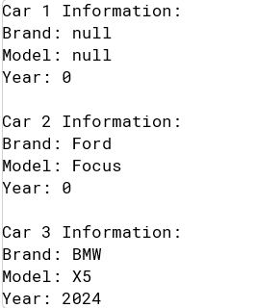

TASK 02
PROGRAM
1. import java.util.Scanner;
2. public class Rectangle{
3. private int length;
4. private int width;
5.
6. public Rectangle(){
7. this.length=3;
8. this.width=4;
9. }
10.
11. public Rectangle(int length,int width){
12. this.length=length;
13. this.width=width;
14. }
15.
16. public Rectangle(int length){
17. this.length=length;
18. this.width=length;
19. }
20.
21. public int calculateArea(){
22. return length*width;
23. }
24.
25. public static void main(String[] args){
26. Scanner sc=new Scanner(System.in);
27. Rectangle obj=new Rectangle();
28.
29. System.out.println("Enter length of rectangle=");
30. int length = sc.nextInt();
31.
32. System.out.println("Enter length of rectangle=");
33. int width = sc.nextInt();
34.
35. Rectangle obj1=new Rectangle(length,width);
36.
37. System.out.println("Enter length of Square=");
38. int len = sc.nextInt();
39.
40. Rectangle obj2=new Rectangle(len);
41.
42. System.out.println("area of reactangle 1:"+obj.calculateArea());
43.
44. System.out.println("area of reactangle 2:"+obj1.calculateArea());
45.
46. System.out.println("area of square:"+obj2.calculateArea());
47. }
48. }

OUTPUT
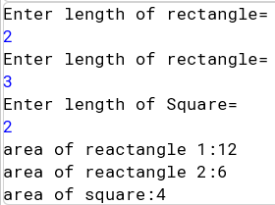

TASK 03
PROGRAM
1. import java.util.Scanner;
2. public class BankAccount{
3. private String HolderName;
4. private double balance;
5.
6. public BankAccount(){ //default constructor
7. this.HolderName="Unknown";
8. this.balance=0.0;
9. }
10.
11. public BankAccount(String HolderName,double balance){ //parameterized constructor that takes both
12. this.HolderName=HolderName;
13. this.balance=balance;
14. }
15.
16. public BankAccount(String HolderName){ ////parameterized constructor that takes balance 1000
17. this.HolderName=HolderName;
18. this.balance=1000;
19. }
20.
21. public void displayAccountDetails(){
22.
23. System.out.println("\nName="+HolderName+"\nBalance="+balance);
24.
25. }
26.
27. public static void main(String[] args){
28. Scanner sc=new Scanner(System.in);
29. BankAccount obj=new BankAccount();
30.
31. System.out.print("enter holder name=");
32. String name=sc.nextLine();
33. System.out.print("enter balanc=");
34. double balance=sc.nextDouble();
35. BankAccount obj1=new BankAccount(name,balance);
36. BankAccount obj2=new BankAccount(name);
37.
38. System.out.println("information for defualt constructor:");
39. obj.displayAccountDetails();
40. System.out.println("information for both parametric constructor:");
41. obj1.displayAccountDetails();
42. System.out.println("information for balance as defualt :");
43. obj2.displayAccountDetails();
44.
45. }
46. }

OUTPUT
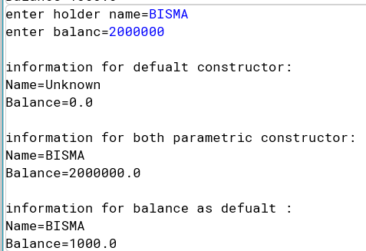
TASK 04
PROGRAM
1. import java.util.Scanner;
2. public class Calculator{
3.
4. public void add(int a,int b){
5. System.out.print("\na+b="+(a+b));
6. }
7.
8. public void add(double a,double b){
9. System.out.print("\na+b="+(a+b));
10. }
11.
12. public void add(String a,String b){
13. System.out.print("\na+b="+(a+b));
14. }
15.
16. public static void main(String[] args){
17. Scanner sc=new Scanner(System.in);
18. Calculator obj=new Calculator();
19. System.out.println("Enter two integer value:");
20. int a=sc.nextInt();
21. int b=sc.nextInt();
22.
23.
24. System.out.println("Enter two doubl value:");
25. double c=sc.nextDouble();
26. double d=sc.nextDouble();
27.
28. sc.nextLine();
29.
30. System.out.println("Enter first string value:");
31. String str1 = sc.nextLine();
32.
33. System.out.println("Enter second string value:");
34. String str2 = sc.nextLine();
35.
36.
37. System.out.println("\naddition of two integer:");
38. obj.add(a,b);
39. System.out.println("\naddition of two double:");
40. obj.add(c,d);
41. System.out.println("\nconcatination of two string:");
42. obj.add(str1,str2);
43. }
44.
45. }

OUTPUT
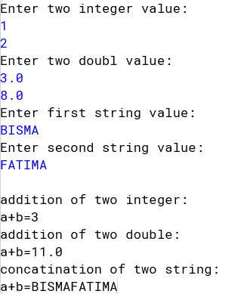
TASK 05
PROGRAM
1. public class Shape{
2.
3. public void draw(String shapeName){
4. System.out.println("Drwaing "+shapeName);
5. }
6.
7. public void draw(String shapeName,int size){
8. System.out.println("Drwaing "+shapeName+"with size "+size);
9. }
10.
11. public void draw(String shapeName,String color){
12. System.out.println("Drwaing "+shapeName+"in "+color);
13. }
14.
15. public static void main(String[] args){
16. Shape obj=new Shape();
17. obj.draw("circle");
18. obj.draw("square",5);
19. obj.draw("pentagon","blue");
20. }
21. }

OUTPUT
